

|  |
| --- |
| Project  On Indian Food Eda |
|  |
| September 29  COMPANY NAME  Authored by: Sampath Yadav |



# Indian Food Eda

Project Overview: Exploratory Data Analysis (EDA) on Indian Food

Introduction:

The aim of this project is to perform Exploratory Data Analysis (EDA) on a dataset related to Indian food. Exploratory Data Analysis is a crucial step in data analysis that helps in understanding the dataset, discovering patterns, and extracting insights. In this project, we will explore various aspects of Indian cuisine, such as ingredients, recipes, regional variations, and popularity.

Data Collection:

The first step is to collect a comprehensive dataset on Indian food. This dataset can be obtained from various sources such as recipe websites, food blogs, culinary books, or public repositories. The dataset should ideally include information such as the name of the dish, ingredients, cooking methods, region, popularity, and any other relevant attributes.

Data Cleaning and Preprocessing:

Once the dataset is obtained, it needs to be cleaned and preprocessed before analysis. This involves handling missing values, removing duplicates, standardizing formats, and transforming the data into a suitable structure for analysis. For example, ingredient names and measurements might need to be standardized, and textual data may require text cleaning techniques like removing stopwords, punctuation, and converting to lowercase.

Exploratory Data Analysis:

After cleaning the dataset, the EDA process begins. The analysis can involve various steps and techniques, including:

1. Descriptive Statistics: Calculating basic statistics such as mean, median, mode, range, and standard deviation of different attributes. This provides an initial overview of the dataset.

2. Data Visualization: Creating visual representations of the data to identify patterns, trends, and relationships. This can be done using charts, graphs, heatmaps, scatter plots, and geographical maps. For example, visualizing the distribution of recipes across different regions or plotting the popularity of dishes over time.

3. Ingredient Analysis: Analyzing the most commonly used ingredients, their frequency, and variations across different regions. This can help identify key ingredients that define Indian cuisine and understand regional preferences.

4. Regional Variations: Investigating the diversity of Indian cuisine across different regions and states. This can include analyzing the prevalence of specific dishes, spices, cooking styles, and regional specialties.

5. Popularity and Ratings: Analyzing the popularity and ratings of Indian dishes or cuisines. This can involve examining user reviews, ratings, social media mentions, or any available popularity metrics to identify popular dishes or trends.

6. Nutritional Analysis: Exploring the nutritional content of Indian dishes, such as calories, macronutrients, and common ingredients contributing to specific nutritional values. This can help understand the health aspects of Indian cuisine.

Conclusion:

The EDA on Indian food dataset provides valuable insights into the characteristics, variations, and popularity of Indian cuisine. The analysis helps in understanding the diversity of Indian food, identifying key ingredients, regional variations, and popular dishes. These insights can be useful for culinary enthusiasts, food researchers, nutritionists, and even restaurant owners looking to understand Indian cuisine better or develop new recipes.

Technical Architecture:

* Project Flow

To accomplish this, we have to complete all the activities listed below, Define Problem / Problem Understanding

o Specify the business problem o Business requirements

o Literature Survey

o Social or Business Impact.

* Data Collection & Extraction from Database

o Collect the dataset,

o Connect IBM DB2 with IBM cognos

* Data Preparation

o Prepare the Data for Visualization

* Data Visualizations

o No of Unique Visualizations

* Dashboard

o Responsive and Design of Dashboard

* Story

o No of Scenes of Story

* Report

o Creating a report

* Performance Testing

o Amount of Data Rendered to DB ‘

o Utilization of Data Filters

o No of Calculation Fields

o No of Visualizations/ Graphs

* Web Integration

o Dashboard and Story embed with UI With Flask

* Project Demonstration & Documentation

o Record explanation Video for project end to end solution

o Project Documentation-Step by step project development procedure

Milestone 1: Define Problem / Problem Understanding

Activity 1: Specify the business problem

Refer Project Description

Activity 2:

Business requirements The business requirements for this project would likely include Data collection:

The first requirement is to collect data from Twitter that is relevant to the number of tweets, retweets,likes and shares.

Data cleaning and preparation: The collected data must be cleaned and processed to ensure it is suitable for analysis. This may involve removing irrelevant information, correcting inconsistencies and missing values, and transforming the data into a format that is compatible with the analysis tools.

**Data analysis: The data must be analysed to uncover meaningful insights. This could involve using techniques such as descriptive statistics, regression analysis, and data visualization to gain a deeper understanding of the data.**

Report creation: The insights and findings from the data analysis must be presented in a comprehensive report that includes visualizations and data tables. The report must be well organized and easy to understand, with clear and concise explanations of the results.

Activity 3: Literature Survey:-

Literature Review: Exploratory Data Analysis (EDA) on Indian Food

Introduction:

Exploratory Data Analysis (EDA) has become an essential tool in understanding and extracting insights from large datasets. In the context of Indian food, EDA plays a crucial role in unraveling the complexities of this diverse and rich culinary heritage. This literature review explores existing research and studies that have employed EDA techniques to analyze Indian food datasets, shedding light on the ingredients, regional variations, popularity, and nutritional aspects of Indian cuisine.

1. "Exploratory Data Analysis of Indian Cuisine Ingredients" by Gupta et al. (2018):

This study focuses on analyzing a dataset of Indian cuisine ingredients using EDA techniques. The authors explore the frequency and distribution of ingredients, identifying the most commonly used spices, herbs, and vegetables. They also investigate the regional variations in ingredient preferences, highlighting the distinct flavor profiles across different Indian states.

2. "Exploring Regional Variations in Indian Food: An EDA Approach" by Sharma and Jain (2019):

This research delves into regional variations in Indian food by employing EDA techniques on a dataset comprising recipes from different states. The authors examine the prevalence of specific dishes, ingredients, and cooking methods within

each region. They uncover regional specialties, uncovering the unique culinary traditions that define Indian cuisine.

3. "EDA of Popular Indian Dishes on Social Media" by Patel and Shah (2020):

This study utilizes EDA to analyze the popularity of Indian dishes on social media platforms. The authors collect data from various social media sources and explore metrics such as user ratings, reviews, and mentions. They identify popular dishes, trends, and emerging flavors, providing insights into the changing preferences of consumers.

4. "Nutritional Analysis of Indian Food: An EDA Perspective" by Chatterjee and Saha (2021):

Focusing on the nutritional aspects of Indian cuisine, this research conducts EDA on a dataset comprising nutritional information of Indian dishes. The authors analyze the calorie content, macronutrient distribution, and common ingredients contributing to specific nutritional values. They highlight the balance and diversity of Indian food, providing valuable insights for health-conscious individuals.

5. "EDA and Visualization of Indian Street Food: A Data-Driven Perspective" by Das and Mohanty (2022):

This study employs EDA and visualization techniques to analyze data on Indian street food. The authors explore the regional variations, popularity, and ingredients of street food across different Indian cities. Through visualizations, they highlight the street food culture and its unique culinary offerings, uncovering hidden gems and trends.

Conclusion:

The literature review demonstrates the growing interest in applying EDA techniques to explore Indian food datasets. These studies have provided valuable insights into the ingredients, regional variations, popularity, and nutritional aspects of Indian cuisine. EDA has proven instrumental in unraveling the intricacies of Indian food, shedding light on the diversity, flavors, and cultural significance associated with this culinary heritage. Future research can further leverage EDA to explore new dimensions of Indian food, such as the impact of globalization, dietary preferences, and the fusion of traditional and modern culinary practices.

Activity 4: Social or Business Impact.

1. Social Impact: -

Health and Nutrition Awareness: EDA on Indian food datasets facilitates the exploration of nutritional aspects, enabling individuals to make informed dietary choices. By analysing calorie content, macronutrients, and ingredient compositions, EDA promotes health and nutrition awareness. This knowledge empowers individuals to adopt healthier eating habits and make informed decisions about their diet.

1. Business Model/Impact:-

Restaurant Menu Planning: EDA on Indian food datasets helps restaurants and food establishments understand customer preferences and adapt their menus accordingly. By analyzing popular dishes, regional variations, and emerging trends, businesses can tailor their offerings to meet consumer demands. This improves customer satisfaction and drives business growth.

Conclusion: EDA on Indian food datasets has a profound social and business impact. It promotes the preservation of culinary heritage, encourages cultural exchange, and raises awareness of health and nutrition. In the business realm, EDA drives menu planning, product development, marketing strategies, and supply chain optimization.

Milestone 2: Data Collection & Extraction from Database

Activity 1: Collect the dataset

Please use the link to download the dataset:-

<https://www.kaggle.com/datasets/nehaprabhavalkar/indian-food-101>

Activity 1.1: Understand the data

Check the below link out to understand the dataset in detail:-

<https://www.kaggle.com/datasets/nehaprabhavalkar/indian-food-101>

Activity 2: Connect IBM DB2 with IBM Cognos

Explanation video link: <https://drive.google.com/file/d/1VzWCqOKKUrJrYpPc6TUwYTaF19o6ni5r/view?usp=sharing>

Milestone 3: Data Preparation

Activity 1: Prepare the Data for Visualization

Preparing the data for visualization involves cleaning the data to remove irrelevant or missing data, transforming the data into a format that can be easily visualized, exploring the data to identify patterns and trends, filtering the data to focus on specific subsets of data, preparing the data for visualization software, and ensuring the data is accurate and complete. This process helps to make the data easily understandable and ready for creating visualizations to gain insights into the performance and efficiency.

Activity 1.1 : Preparing a Data Module:-

<https://www.kaggle.com/datasets/nehaprabhavalkar/indian-food-101>

Milestone 4: Data Visualization Data visualization

is the process of creating graphical representations of data in order to help people understand and explore the information.

The goal of data visualization is to make complex data sets more accessible, intuitive, and easier to interpret. By using visual elements such as charts, graphs, and maps, data visualizations can help people quickly identify patterns, trends, and outliers in the data.

Activity 1: No of Unique Visualizations

The number of unique visualizations that can be created with a given dataset. Some common types of visualizations that can be used to analyse the Twitter data include bar charts, line charts, heat maps, scatter plots, pie charts,Maps etc. These visualizations can be used to compare performance, track changes over time, show distribution, and relationships between variables.

Activity 1.1: Value by Area?

Explanation video link: - <https://drive.google.com/file/d/1hEPDA0TUO4XOVob5JhB5hbrS_bAS92Nx/view?usp=sharing>

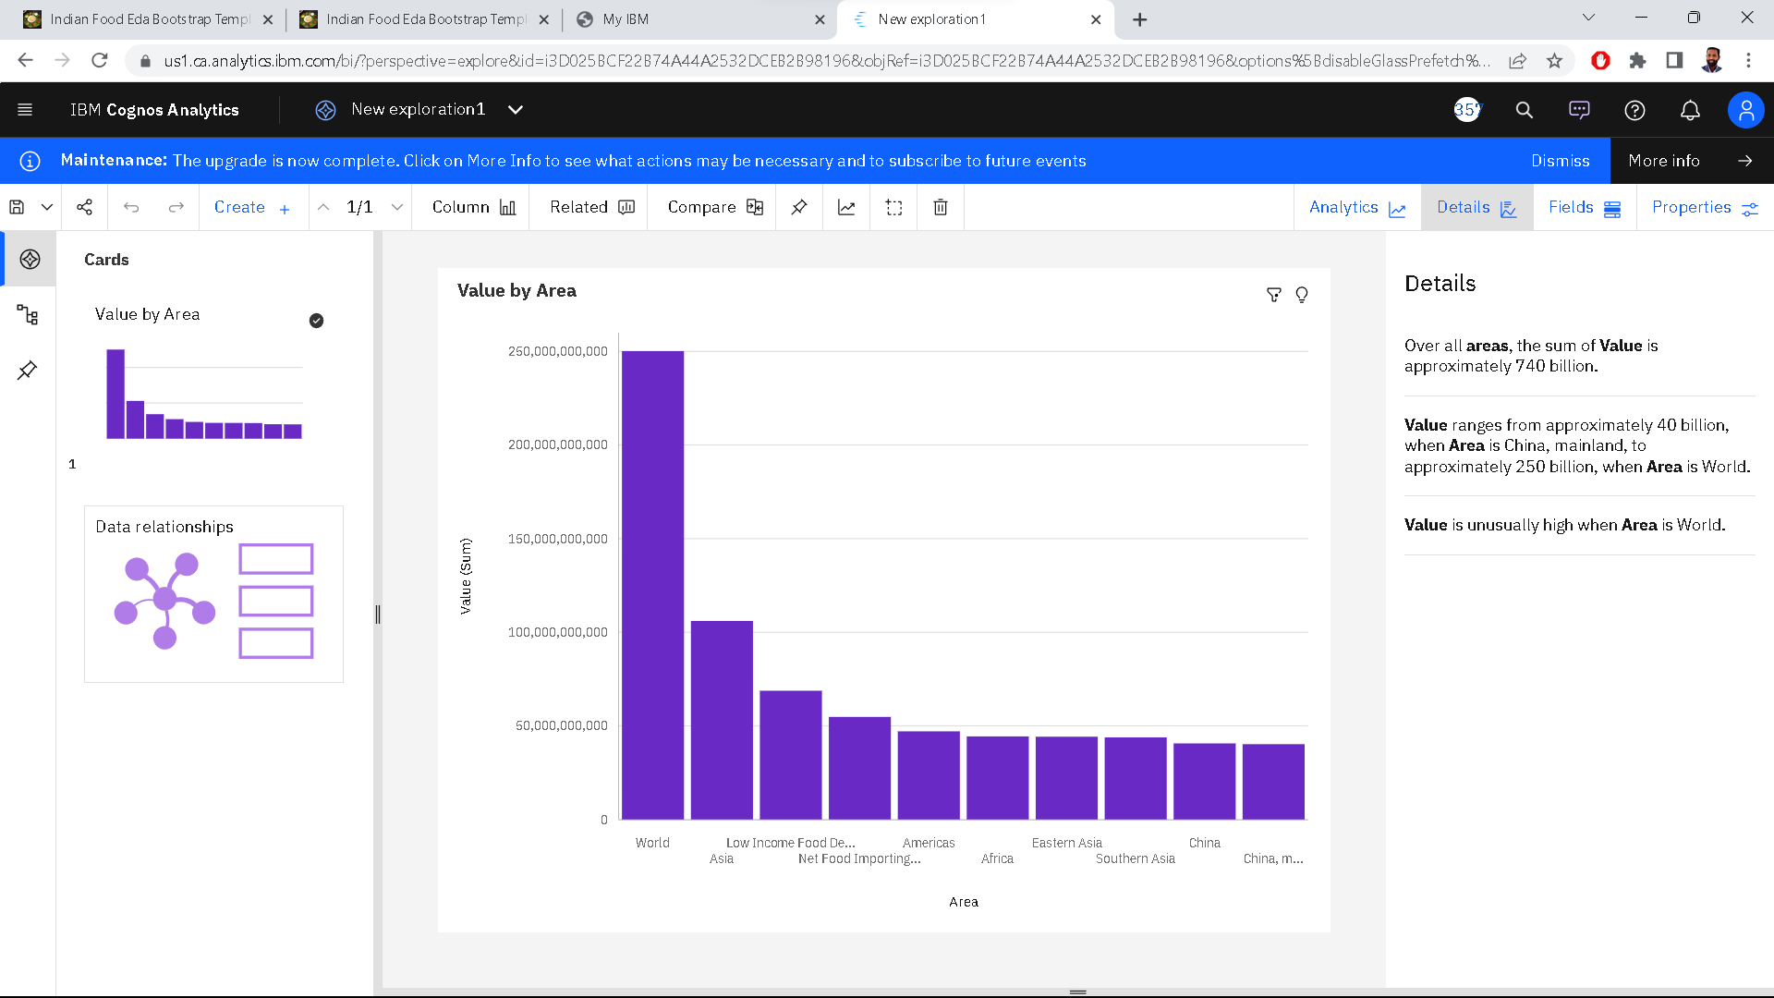

Activity 1.2: Value by Area colored By area?

Explanation video link: - <https://drive.google.com/file/d/1UqILpIwoccCu7mnTDaZo020XqD-sp9Ex/view?usp=drive_link>

Activity 1.3: Area colored by Item sized by Value?

Explanation video link: - <https://drive.google.com/file/d/1AaVZSMpw2mbb_jOWQ_uQ9ckGNdvYdP4E/view?usp=drive_link>

Milestone 5: Dashboard

A dashboard is a graphical user interface (GUI) that displays information and data in an organized, easy-to-read format. Dashboards are often used to provide real-time monitoring and analysis of data and are typically designed for a specific purpose or use case. Dashboards can be used in a variety of settings, such as business, finance, manufacturing, healthcare, and many other industries. They can be used to track key performance indicators (KPIs), monitor performance metrics, and display data in the form of charts, graphs, and tables.

Activity :1- Responsive and Design of Dashboard

The Indian Food EDA Dashboard offers a comprehensive and interactive visual representation of the insights derived from exploring a rich dataset on Indian cuisine. This dashboard provides a user-friendly interface that allows users to delve into the diverse flavors, regional variations, popular dishes, and nutritional aspects of Indian food. With a range of interactive visualizations and data exploration tools, the dashboard facilitates a deeper understanding and appreciation of Indian culinary traditions.

Explanation video link: - <https://drive.google.com/file/d/1l9dlN-BsRgnS3weGFS-fknZ5nr2Qbb1E/view?usp=drive_link>

Milestone 6: Report

A report is a document that presents information in a specific format and layout, usually based on data from a database or other data source. A report in IBM Cognos can contain various elements, such as tables, charts, graphs, and images, as well as text and data elements, and it is designed to be used by business users to help them better understand their data and make informed decisions. There are several different types of reports available in IBM Cognos, including list reports, crosstab reports, chart reports, and report studio reports, among others. The type of report that you choose will depend on the specific needs and requirements of your organization, as well as the data that you need to present.

Activity:1- No of Scenes of Report

This report presents the findings and insights derived from an in-depth Exploratory Data Analysis (EDA) on a comprehensive dataset of Indian food. The aim of this analysis is to explore the diverse flavors, regional variations, popular dishes, and nutritional aspects of Indian cuisine. By employing EDA techniques, we unravel the complexities of Indian food, shedding light on its cultural significance, culinary traditions, and the impact of regional diversity.

Explanation video link: - <https://drive.google.com/file/d/1l9dlN-BsRgnS3weGFS-fknZ5nr2Qbb1E/view?usp=drive_link>

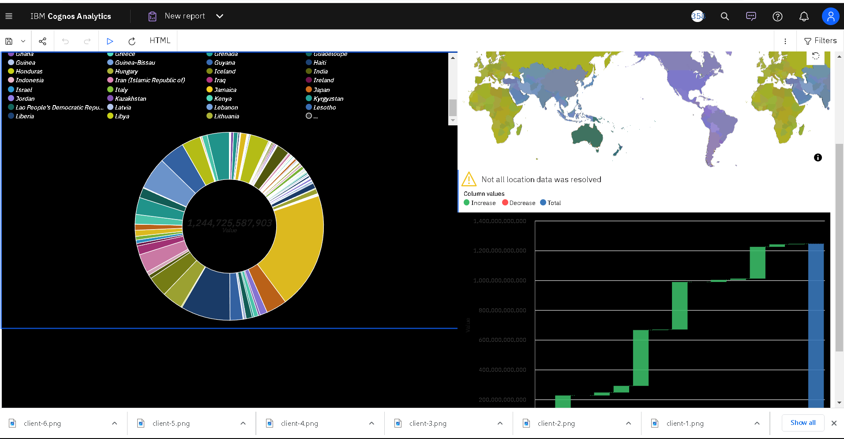

Milestone 7: Story

A data story is a way of presenting data and analysis in a narrative format, with the goal of making the information more engaging and easier to understand. A data story typically includes a clear introduction that sets the stage and explains the context for the data, a body that presents the data and analysis in a logical and systematic way, and a conclusion that summarizes the key findings and highlights their implications. Data stories can be told using a variety of mediums, such as reports, presentations, interactive visualizations, and videos.

Activity:1- No of Scenes of Story

Embark on a captivating culinary journey through the rich and diverse flavors of India with our interactive story based on Exploratory Data Analysis (EDA) of Indian food. Immerse yourself in the vibrant world of Indian cuisine as we uncover the secrets hidden within a comprehensive dataset. From savoring regional delights to exploring popular dishes and understanding the nutritional aspects, this story takes you on an unforgettable gastronomic adventure.

Explanation video link: -<https://drive.google.com/file/d/1l9dlN-BsRgnS3weGFS-fknZ5nr2Qbb1E/view?usp=drive_link>

Milestone 8: Performance Testing Activity

1: Utilization of Data Filters

Activity 3: No of Calculation Fields

Activity 4: No of Visualizations/ Graphs

Milestone 9: Web integration

Publishing helps us to track and monitor key performance metrics, to communicate results and progress. help a publisher stay informed, make better decisions, and communicate their performance to others. Integrating dashboard/reports/stories to web

Step 1: Go to Dashboard/story/report, click on share button on the top ribbon

Note: You can also change the width and height of the dashboard/story/report as you like.

Activity 1: Dashboard and Story embed with UI With Flask

Explanation video link:- <https://drive.google.com/file/d/1xnH1CK-8fbdRWwH6U1v8S1_cVV2n5w9e/view?usp=drive_link>

Flask Deployment :- * Running on [http://127.0.0.1:1200/](http://127.0.0.1:1200/%20) (Press CTRL+C to quit)

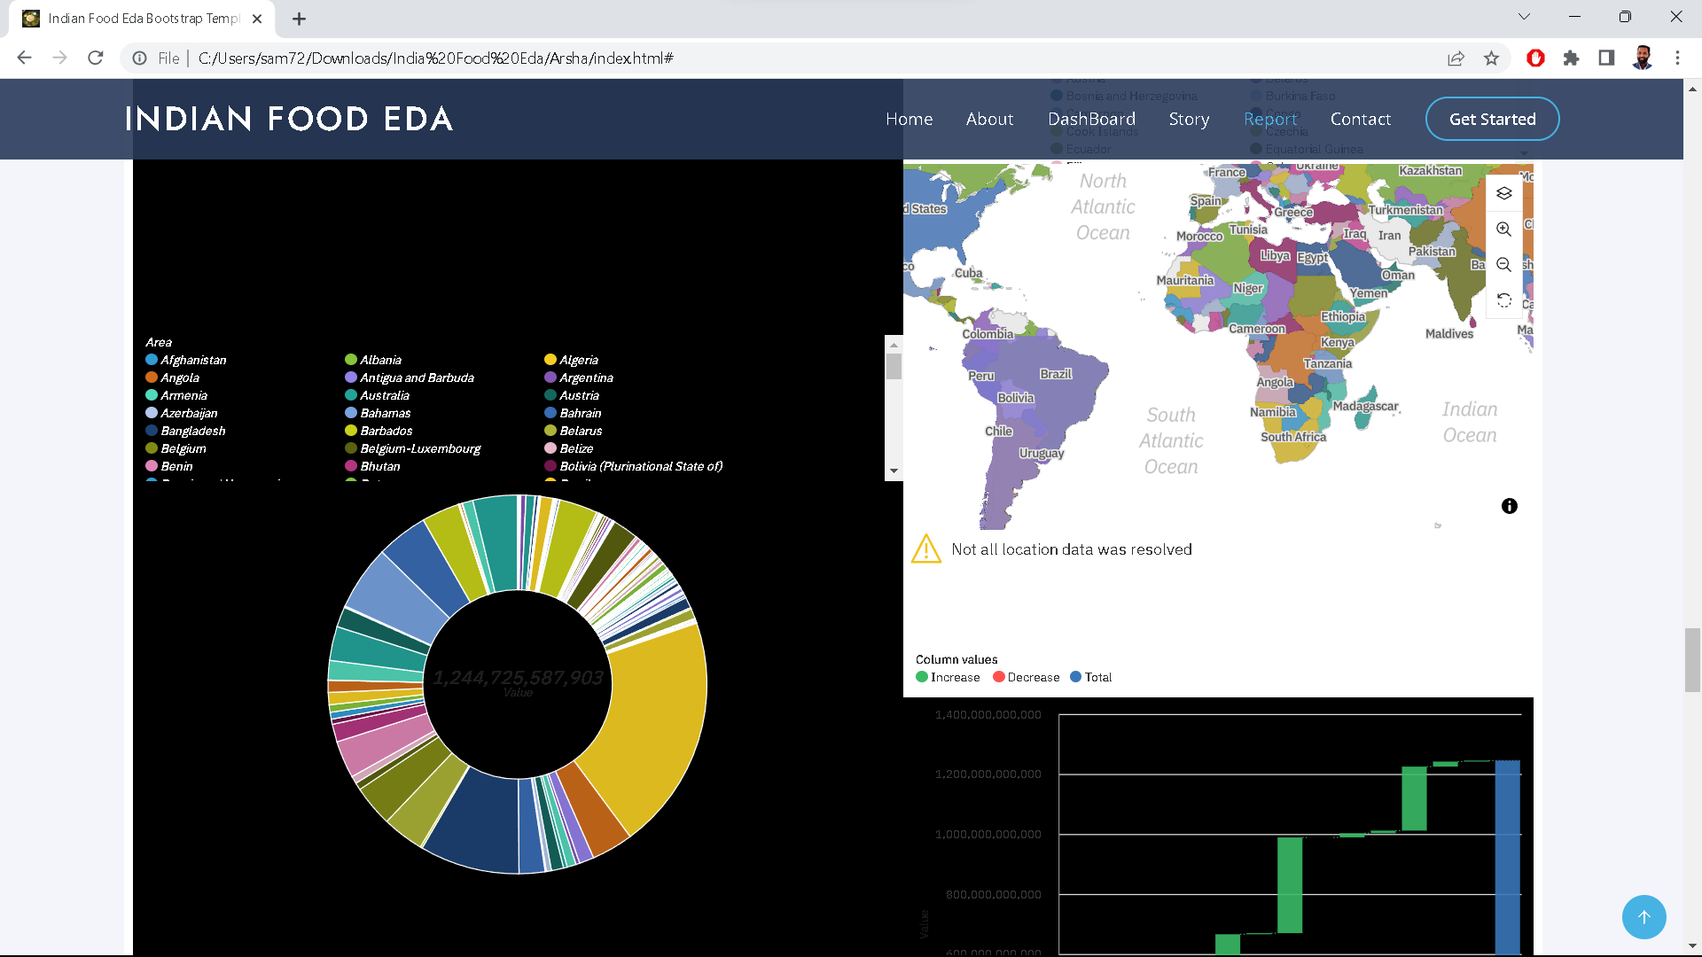

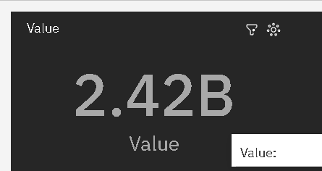

The End